21BDS0340

Abhinav Dinesh Srivatsa

Exploratory Data Analysis Lab

Practice Problem Set – 2

**Experiment 3**

Code:

library(dplyr)

library(tidyr)

library(magrittr)

setwd("/Users/abhi/College Work/Year 4 Semester 1 (Sem 7)/Exploratory Data Analysis Lab/Assignment 2")

data = read.csv("DS2_Match.csv")

Output:

> setwd("/Users/abhi/College Work/Year 4 Semester 1 (Sem 7)/Exploratory Data Analysis Lab/Assignment 2")

> data = read.csv("DS2_Match.csv")

> library(dplyr)

> library(tidyr)

> library(magrittr)

> setwd("/Users/abhi/College Work/Year 4 Semester 1 (Sem 7)/Exploratory Data Analysis Lab/Assignment 2")

> data = read.csv("DS2_Match.csv")

Code:

win_type_arranged = data %>% arrange(Win_Type)

View(win_type_arranged)

Output:

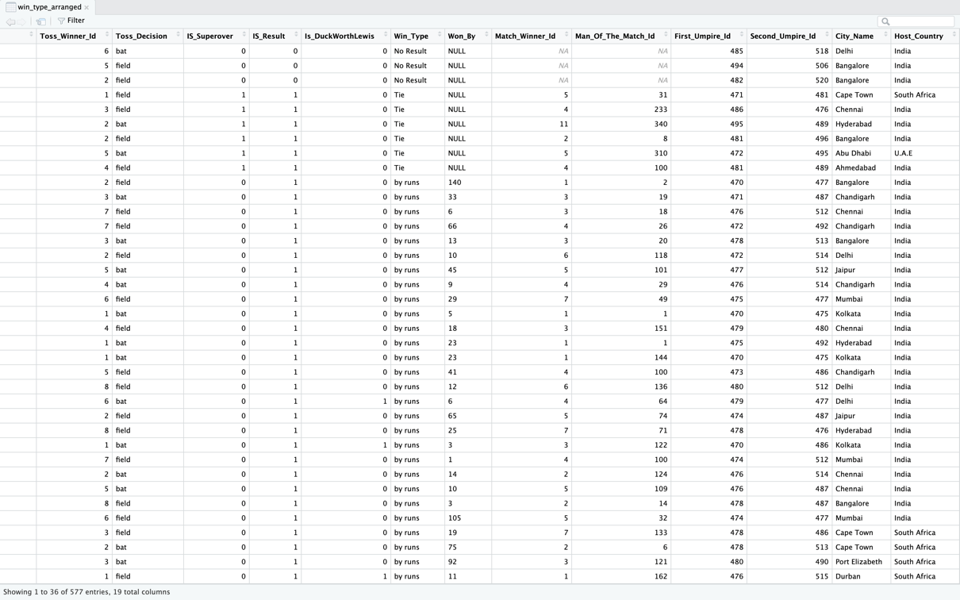

Code:

city_name_arranged = data %>% arrange(City_Name)

View(city_name_arranged)

Output:

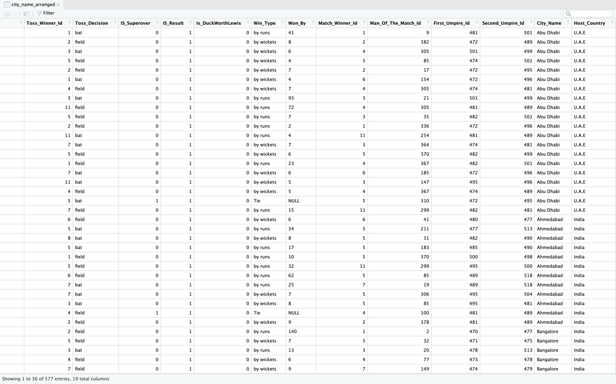

Code:

match_dates = data %>% select(Match_Date)

View(match_dates)

Output:

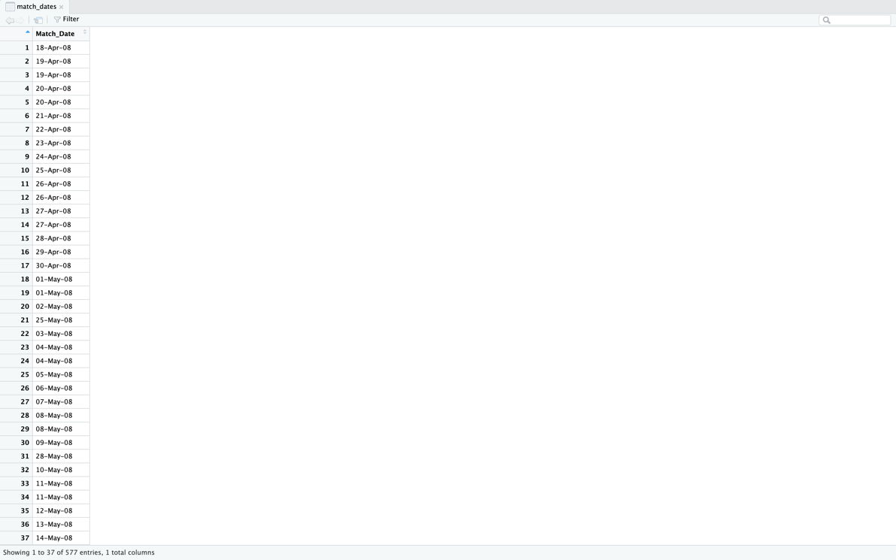

Code:

city_and_country = data %>% select(City_Name, Host_Country)

View(city_and_country)

Output:

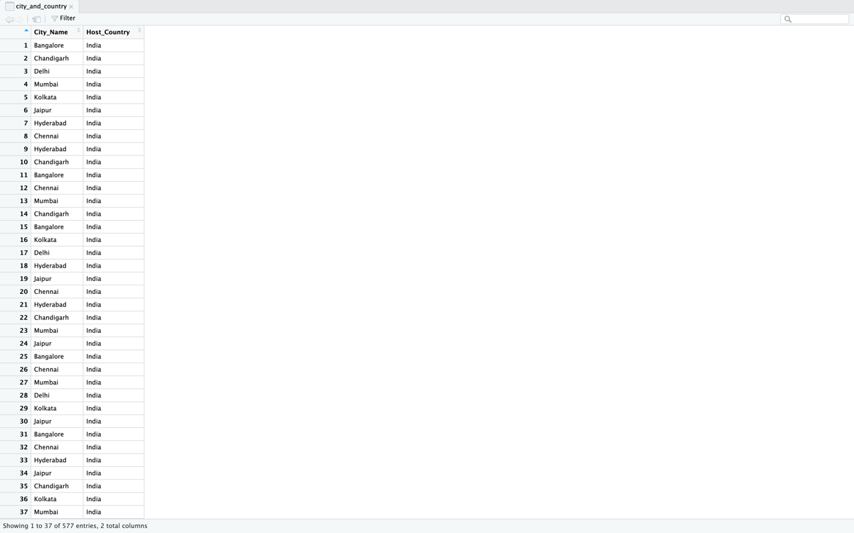

Code:

all_but_match_id = data %>% select(-Match_Id)

View(all_but_match_id)

Output:

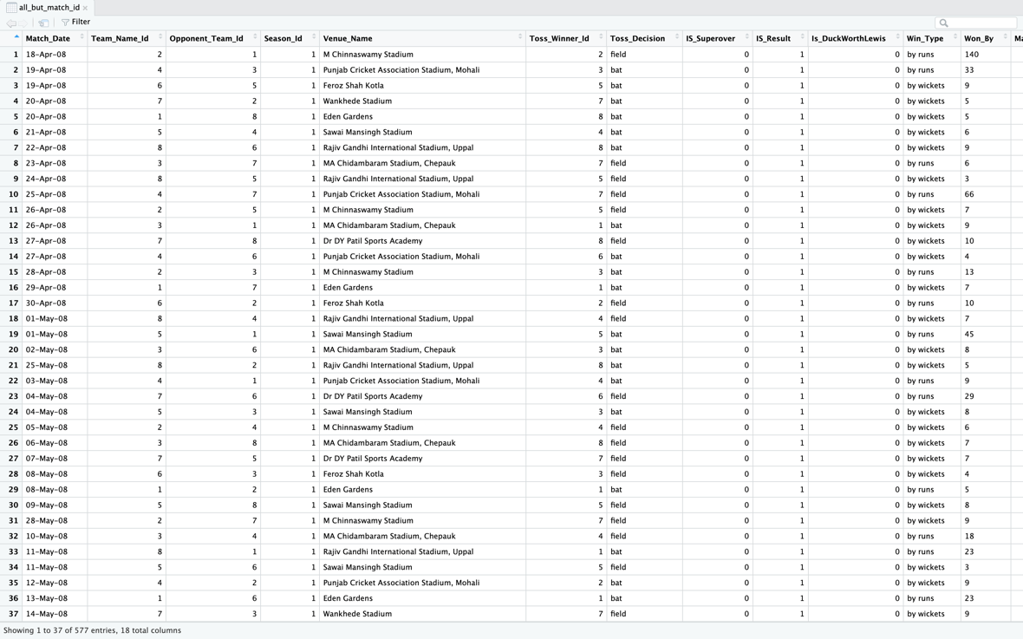

Code:

bangalore_matches = data %>% filter(City_Name == "Bangalore")

View(bangalore_matches)

Output:

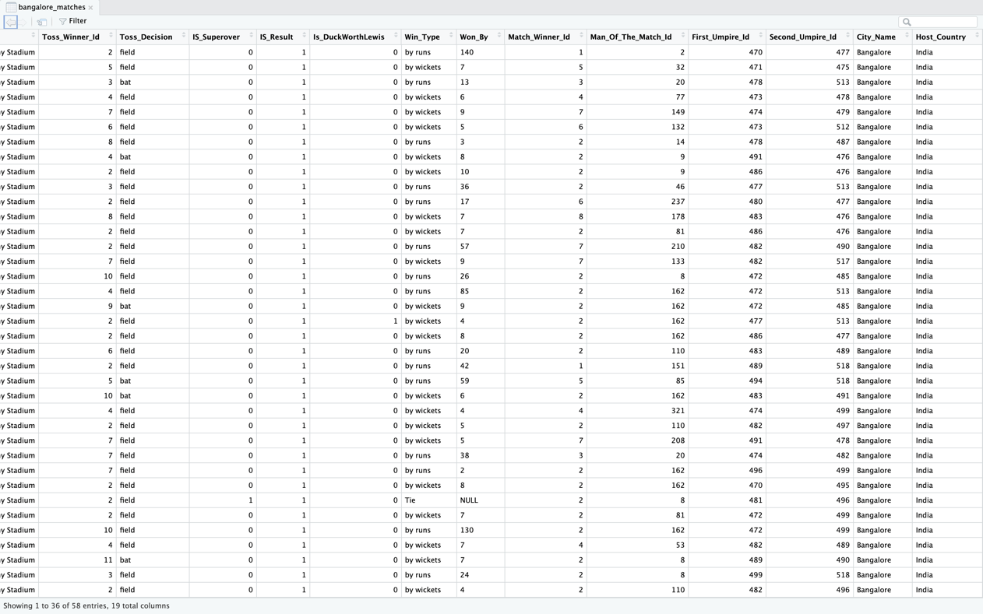

Code:

no_result_matches = data %>% filter(Win_Type == "No Result")

View(no_result_matches)

Output:

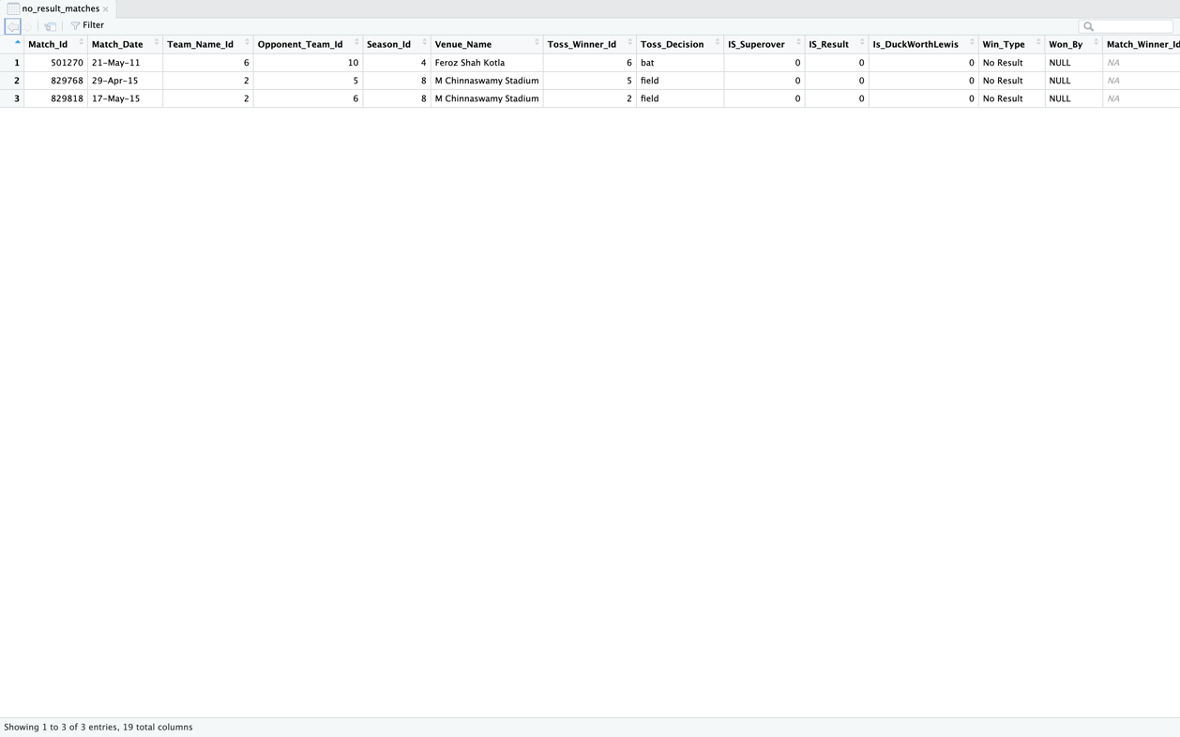

Code:

india_bat_matches = data %>% filter(Host_Country == "India", Toss_Decision == "bat")

View(india_bat_matches)

Output:

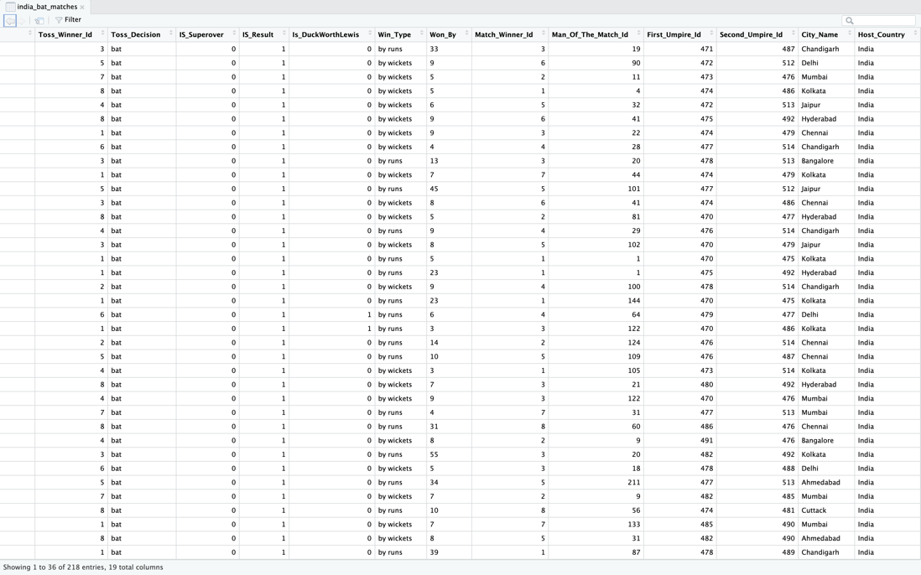

Code:

custom_data = data.frame(

Name = c("Abhinav", "Tanush", "Sumathi"),

English = c(45, 67, 87),

Math = c(53, 65, 23)

)

gathered = custom_data %>% gather("Course", "Marks", 2:3)

View(gathered)

Output:

Code:

spread = gathered %>% spread("Course", "Marks")

View(spread)

Output:

Code:

grouped = data %>% group_by(Host_Country) %>%

summarise(count = n())

View(grouped)

Output:

Code:

mutated = data %>% mutate(year=format(as.Date(data$Match_Date, format="%d-%b-%y"), "%Y"))

View(mutated)

Output:

**Experiment 4**

Code:

library(dplyr)

library(ggplot2)

library(lubridate)

setwd("/Users/abhi/College Work/Year 4 Semester 1 (Sem 7)/Exploratory Data Analysis Lab/Assignment 2")

data = read.csv("./DS2_Match.csv")

Output:

> library(dplyr)

> library(ggplot2)

> library(lubridate)

> setwd("/Users/abhi/College Work/Year 4 Semester 1 (Sem 7)/Exploratory Data Analysis Lab/Assignment 2")

> data = read.csv("./DS2_Match.csv")

Code:

# viewing data

View(data)

Output:

Code:

# dimentions and names of columns

dim(data)

names(data)

Output:

> dim(data)

[1] 577 19

> names(data)

[1] "Match_Id" "Match_Date" "Team_Name_Id" "Opponent_Team_Id"

[5] "Season_Id" "Venue_Name" "Toss_Winner_Id" "Toss_Decision"

[9] "IS_Superover" "IS_Result" "Is_DuckWorthLewis" "Win_Type"

[13] "Won_By" "Match_Winner_Id" "Man_Of_The_Match_Id" "First_Umpire_Id"

[17] "Second_Umpire_Id" "City_Name" "Host_Country"

Code:

# sorting data by win type

head(sort(data$Win_Type))

Output:

> head(sort(data$Win_Type))

[1] "by runs" "by runs" "by runs" "by runs" "by runs" "by runs"

Code:

# summary of data

summary(data)

Output:

> summary(data)

Match_Id Match_Date Team_Name_Id Opponent_Team_Id Season_Id

Min. :335987 Length:577 Min. : 1.000 Min. : 1.000 Min. :1.000

1st Qu.:419140 Class :character 1st Qu.: 3.000 1st Qu.: 3.000 1st Qu.:3.000

Median :548353 Mode :character Median : 5.000 Median : 5.000 Median :5.000

Mean :591636 Mean : 5.102 Mean : 5.211 Mean :5.029

3rd Qu.:734004 3rd Qu.: 7.000 3rd Qu.: 7.000 3rd Qu.:7.000

Max. :981024 Max. :13.000 Max. :13.000 Max. :9.000

Venue_Name Toss_Winner_Id Toss_Decision IS_Superover IS_Result

Length:577 Min. : 1.000 Length:577 Min. :0.0000 Min. :0.0000

Class :character 1st Qu.: 3.000 Class :character 1st Qu.:0.0000 1st Qu.:1.0000

Mode :character Median : 5.000 Mode :character Median :0.0000 Median :1.0000

Mean : 5.192 Mean :0.0104 Mean :0.9948

3rd Qu.: 7.000 3rd Qu.:0.0000 3rd Qu.:1.0000

Max. :13.000 Max. :1.0000 Max. :1.0000

Is_DuckWorthLewis Win_Type Won_By Match_Winner_Id

Min. :0.000 Length:577 Length:577 Min. : 1.000

1st Qu.:0.000 Class :character Class :character 1st Qu.: 3.000

Median :0.000 Mode :character Mode :character Median : 5.000

Mean :0.026 Mean : 4.991

3rd Qu.:0.000 3rd Qu.: 7.000

Max. :1.000 Max. :13.000

NA's :3

Man_Of_The_Match_Id First_Umpire_Id Second_Umpire_Id City_Name Host_Country

Min. : 1.0 Min. :470.0 Min. :471.0 Length:577 Length:577

1st Qu.: 40.0 1st Qu.:475.0 1st Qu.:488.0 Class :character Class :character

Median :105.5 Median :482.0 Median :493.0 Mode :character Mode :character

Mean :139.8 Mean :484.1 Mean :495.2

3rd Qu.:209.5 3rd Qu.:493.0 3rd Qu.:500.0

Max. :460.0 Max. :511.0 Max. :521.0

NA's :3

Code:

# finding min and max of first umpire id

min(data$First_Umpire_Id)

max(data$First_Umpire_Id)

Output:

> min(data$First_Umpire_Id)

[1] 470

> max(data$First_Umpire_Id)

[1] 511

Code:

# finding mean and median of won by amount

data$Won_By = sapply(data$Won_By, function(x) {

if (x == "NULL") {

return(0)

}

x

})

data$Won_By = as.numeric(data$Won_By)

mean(data$Won_By)

median(data$Won_By)

Output:

> mean(data$Won_By)

[1] 17.07972

> median(data$Won_By)

[1] 8

Code:

# finding quantiles of won by

quantile(data$Won_By)

Output:

> quantile(data$Won_By)

0% 25% 50% 75% 100%

0 6 8 20 144

Code:

# checking NaN values (if cleanup is required)

sum(apply(data, 2, is.nan))

Output:

[1] 0

Code:

# check different host countries

levels(factor(data$Host_Country))

Output:

[1] "India" "South Africa" "U.A.E"

Code:

# plotting by host country

country_counts = data %>%

group_by(Host_Country) %>%

summarise(count = length(Host_Country))

pie(country_counts$count, labels=country_counts$Host_Country)

Output:

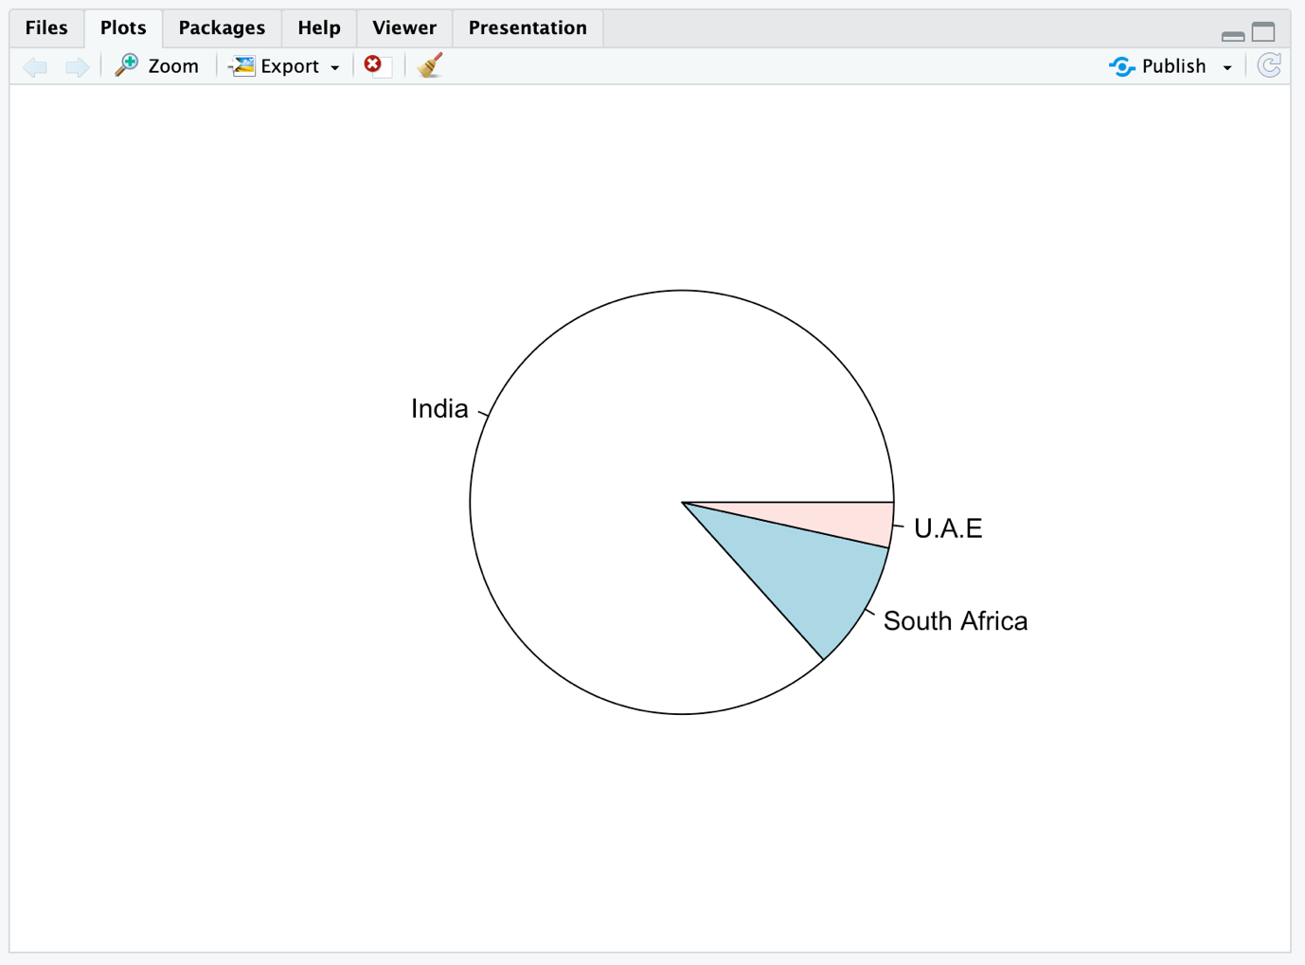

Code:

# check different win conditions

levels(factor(data$Win_Type))

Output:

[1] "by runs" "by wickets" "No Result" "Tie"

Code:

# plotting by win condition

win_cond_count = data %>%

group_by(Win_Type) %>%

summarise(count = length(Win_Type))

barplot(win_cond_count$count, xlab="Win Condition", ylab="Count", names.arg=win_cond_count$Win_Type, col="cyan")

Output:

Code:

# check different city names

levels(factor(data$City_Name))

Output:

[1] "Abu Dhabi" "Ahmedabad" "Bangalore" "Bloemfontein" "Cape Town"

[6] "Centurion" "Chandigarh" "Chennai" "Cuttack" "Delhi"

[11] "Dharamsala" "Durban" "East London" "Hyderabad" "Indore"

[16] "Jaipur" "Johannesburg" "Kanpur" "Kimberley" "Kochi"

[21] "Kolkata" "Mumbai" "Nagpur" "Port Elizabeth" "Pune"

[26] "Raipur" "Rajkot" "Ranchi" "Visakhapatnam"

Code:

# plotting by city name, color by host country

city = data %>%

group_by(City_Name, Host_Country) %>%

summarise(count = length(City_Name))

ggplot(city, aes(x=City_Name, y=count, fill=Host_Country)) +

geom_bar(stat="identity") +

geom_text(aes(label=City_Name), vjust=0.5, angle=90, hjust=0) + scale_x_discrete(labels=NULL) +

ylim(0, 100) +

labs(x="City", y="Matches")

Output:

Code:

# casting match date column to date type

match_dates = data.frame(date=as.Date(data$Match_Date, format="%d-%b-%y"))

head(match_dates, 2)

Output:

date

1 2008-04-18

2 2008-04-19

Code:

# finding the matches played per month

match_dates = match_dates %>%

mutate(month=month(date)) %>%

group_by(month) %>%

summarise(count=length(month))

head(match_dates)

Output:

# A tibble: 4 × 2

month count

<dbl> <int>

1 3 29

2 4 261

3 5 285

4 6 2

Code:

# plotting matches played by month

ggplot(match_dates, aes(x=month, y=count, fill=month)) +

geom_bar(stat="identity") +

geom_text(aes(label=month.name[month]), vjust=-0.5) +

labs(x="Month", y="Matches Played")

Output:

